EMERGING METHODS FOR EARLY DETECTION OF FOREST FIRES

**NALAIYA THIRAN PROJECT BASED LEARNING ON PROFESSIONAL READLINESS FOR INNOVATION, EMPLOYNMENT AND ENTERPRENEURSHIP**

# 

# A PROJECT REPORT

***Submitted by***

**HARITHA G D**

**DURGA G**

**DHIVYA BHARATHI S**

**GEETHAPRIYA N**

**TEAM ID :** PNT2022TMID53582

**INDUSTRY MENTOR :** Shanthi

**FACULTY MENTOR : Dr.GAYATHRI R**

**COLLEGE NAME : SRI VENKATESWARA COLLEGE OF ENGINEERING**

**PROJECT REPORT**

1. **INTRODUCTION**
   1. Project Overview
   2. Purpose
2. **LITERATURE SURVEY**
   1. Existing problem
   2. References
   3. Problem Statement Deﬁnition
3. **IDEATION & PROPOSED SOLUTION**
   1. Empathy Map Canvas
   2. Proposed Solution
   3. Problem Solution ﬁt
4. **REQUIREMENT ANALYSIS**
   1. Functional requirement
   2. Non-Functional requirements
5. **PROJECT DESIGN**
   1. Data Flow Diagrams
   2. Solution & Technical Architecture
   3. User Stories
6. **PROJECT PLANNING & SCHEDULING**
   1. Sprint Planning & Estimation
   2. Sprint Delivery Schedule
   3. Reports from JIRA
7. **CODING & SOLUTIONING** (Explain the features added in the project along with code)
   1. Feature 1
   2. Feature 2
   3. Database Schema (if Applicable)
8. **TESTING**
   1. Test Cases
   2. User Acceptance Testing
9. **RESULTS**
   1. Performance Metrics
10. **ADVANTAGES & DISADVANTAGES**
11. **CONCLUSION**
12. **FUTURE SCOPE**
13. **APPENDIX**

Source Code

GitHub & Project Demo Link

1. **INTRODUCTION**

**1.1 Project overview:**

Fire can make major hazards in this hectic world. All buildings and vehicles used in public transportation have fire prevention and fire protection systems due to the accelerated number in the fire incidents. Also, many of the firms conduct a mock fire drill in every occurrence of months to protect their employees from the fire. This would help them to understand what to do or what not to do when a fire situation happens. Forests are one of the main factors in balancing the ecology. It is very harmful when a fire occurs in a forest. But most of the time, the detection of forest fire happens when it spread over a wide region. Sometimes, it could not be possible to stop the fire. As a result, the damage of the environment is higher than predictable. The emission of large amount of carbon dioxide (CO2) from the forest fire damages the environment. As well as it would lead to complete disappearance of rare species in the world. Also, it can make an impact on the weather, and this make major issues like earthquakes, heavy rains, floods and so on.

A research study shows an automatic fire detection can be divided into three groups: aerial, ground and borne detection. The ground-based systems use several staring black and white video cameras are used in fire detection which detect the smoke and compares it with the natural smoke. The main benefit of using this system is high temporal resolution and spatial resolution. So that, the detection is easier.2But these mechanisms still have some drawbacks in detecting the early stage of the fire. So that, it is highly important to introduce a system to detect the fire early as possible.

Moreover, information regarding the seat of the hearth is invaluable for the rapid deployment of ﬁre- ﬁghters. Therefore, early detection, containment at the primary stages and extinguishment of a ﬁreplace before it spreads are crucial for wildﬁre Management.

* 1. **Purpose**

Forest ﬁres as of late have been annihilating both for normal biological system, biodiversity and woodland economy. With expanding populace weight and change in worldwide atmosphere situation, there is an expansion in level of ﬁres that are a signiﬁcant reason for declining Indian woodlands. As indicated by woodland study report of India, 50 % of backwoods regions in nation are ﬁre inclined (going from 50 to 90 % in certain conditions of nation). Around 6 % of the woods are inclined to extreme ﬁre harms. The reason for this planned framework is to

manufacture a dependable ﬁre location framework so as to know dynamic status of backwoods temperature in speciﬁc conditions. It is about the sensors and dynamic checking framework to dodge a signiﬁcant ﬁre and genuine harm to woods.

**2. LITERATURE SURVEY**

**2.1Existing problem**

The existing system for detecting ﬁre are smoke alarms and heat alarms. The main disadvantage of the smoke sensor alarm and heat sensor alarms are that just one module is not enough to monitor all the potential ﬁre prone places. The only way to prevent ﬁre is to cautious at the time. Even if they are installed in every nook and

corner, it just is not suﬃcient for an eﬃcient output consistently. As the number of smoke sensor requirement increase the cost will also increase to its multiple. The proposed system can produce consistent and highly accurate alerts within seconds of accident of the ﬁre. It reduces cost because only one software is enough to power the entire network of surveillance. Research is active on this ﬁeld by data scientists and machine learning researchers. The real challenge is to minimize the error in detection of ﬁre and sending alerts at the right time.The idea of this research is to fabricate a system through IoT sensors, which is arbitrarily spread in the forest and to make a self-sorted out powerful system between the sensors to cover all the enormous territories in the forest that will used to maintain a strategic distance from the ﬁre harm whenever. The capacity of the sensor is to identify ﬁre in the inclusion region between the time intermission of each 5-10 minutes. At the point when the ﬁre is recognized the entirety of the sensor in the region will be dynamic and order to stop the normal assignment. The concept is to build early ﬁre detector using Arduino which is connected with different IoT sensors. Putting all efforts to develop a smarter system by connecting it to a webpage and monitoring the developed system statistics controlled by the Arduino programming. The use of latest technology can help to prevent the catastrophic accidents in forests. The aim is to early detect the ﬁreplace in forest by considering the several factor like smoke, temperature, humidity, ﬂame and based on the data we get from this programming, the forest department will be able to take an appropriate decision and the rescue team will be able to arrive on time at exact location. Consider, if it is a large region and it produces more carbon monoxide than the ordinary vehicle traﬃc. Surveillance of the danger areas and an early detection of ﬁreplace can appreciably shorten the response time and additionally decrease the practicable injury as nicely as the fee of ﬁreﬁghting. Known rule applies here: 1 minute – 1 cup of water, 2 minutes - 100 liters of water, 10 minutes - 1000 liters of water. The goal is to notice the ﬁreplace as quicker as possible, its actual localization and early notiﬁcation to the ﬁre devices. When ﬁre starts then the ﬂammable texture may likewise issues fuel to the hearth focal spot. The spot at that point will expand and more extensive. The ﬁrst phase of start is alluded as "surface ﬁre‟ stage. This may feed on abutting bushes and the ﬁre will turn into higher and transforming into "crown ﬁre‟. Generally, at this stage the hearth transforms into wild and injury which end up being extreme that could stay for quite long time while depending on atmosphere conditions and the territory. Forest ﬁre detection using optimized solar–powered ZigBee wireless sensor networks- In this paper, they have developed system for Forest Fire Detection which overcomes the demerits of the Existing technologies of Forest Fire Detection. It can be ensured that the system developed can be implemented on a large scale with its promising results. The system is provided with low-power elements, higher versions of Zigbee, Maximum power point tracking Algorithm is used in order to make the system run for longer periods eﬃciently. Forest ﬁres are a very serious problem in many countries, and global warming may contribute to make this problem worse. Experts agree that, in order to prevent these tragedies from happening, it is necessary to invest in new technologies and equipment that enable a multifaceted approach. This paper describes a WSN for early detection of forest ﬁres. This network can be easily deployed at areas of special interest or risk. There are two types of nodes from the physical structure point of view: SNs, to collect data from the environment, and CNs, to gather data from the SNs and transmit the information to a Control Centre. The nodes also can be in different functioning modes. This enables a proper and seamless conﬁguration of the network, provides redundancy, and ensures there will be full temporal and geographical coverage in the deployment zone. The information gathered is related not only to early detection purposes but also to environment monitoring to maximize the WSN usage. This environmental data can also be employed to ﬁreﬁghting preventive tasks such as vegetation modelling, microclimate studies, and propagation model parametrization.

In this paper, a forest ﬁre detection algorithm is proposed. The algorithm uses YCbCr color space since it effectively separates luminance from chrominance and is able to separate high temperature ﬁre center pixels because the ﬁre at the high temperature center region is white. The ﬁnal results show that the proposed system has good detection rates and fewer false alarms, which are the main crucial problems of the most existing algorithms. The presences of ﬁre in video streams are indicated by semantic events. Most of the existing systems can only be used for the videos obtained from stationary cameras and videos obtained from the controlled lightening conditions. These existing automatic ﬁre detection systems cannot be used for video

streams obtained from mobile phones or any hand held devices. It was decried as a global tragedy. Lit by farmers, the ﬁres raged through villages, destroyed ecosystems and pumped climate-warming pollution into the atmosphere.

* 1. **References**
     + V.Parthipan, D.Dhanasekaran,“ Preventing and Monitoring of Framework for Forest Fire Detection and Data Analysis Using Internet of Things (IoT)“, IJEAT, ISSN: 2249 – 8958, Volume-8, Issue-3S February 2019.
     + Shijo Joseph, K. Anitha, M.S.R. Murthy,” Forest ﬁre in India: a review of the knowledge base”,J For Res(2009) 14:127-134.
     + Ranjth E, Padmabalaji D, Sibisubramanian S, Radhika S,” An IOT Based Forest Fire Detection and Prevention System using Raspberry PI 3“, IRJET, eISSN: 2395- 0056, p-ISSN: 2395-0072, Volume: 06 Issue: 03, Mar 2019.
     + M. Trinath Basu, Ragipati Karthik, J. Mahitha, V. Lokesh Reddy,“IoT Based Forest Fire Detection System“, IJET, 7(2.7) (2018) 124-126.
     + T. Saikumar, P. Sriramya, „“IoT Enabled Forest Fire Detection and Alerting the Authorities“, IJRTE, ISSN: 2277-3878, Volume-7, Issue-6S4, April 2019. 6. Wolfgang KRÜLL, Robert TOBERA, Ingolf WILLMS, , Helmut ESSEN, Nora von WAHL,“ Early forest ﬁre detection and veriﬁcation using optical smoke, gas and microwave sensors“, / Procedia Engineering 45 ( 2012

) 584 – 594.

* + - Stanmir Zivanovic, Darko Zigar, Dejan Krstic, “The Role of Early Detection of Forest Fire in Environmental Protection“, Safety Engineering, Vol 3, N2 (2013) 93-97. ⦁ Antonio Molina-Pico, David Cuesta-Frau, Alvaro Araujo, Javier Alejandre, Alba Rozas,“Forest Monitoring and Wildland Early Fire Detection by a Hierarchical Wireless Sensor Network“, Volume 2016

|Article ID 8325845 | 8 pages, Source: Hindawi.

* Ahmad A. A. Alkhatib, “A Review on Forest Fire Detection Techniques“, Volume 2014, Article ID 597368,12 Pages, Source: Hindawi.
* Yasar Guneri Sahin, Turker Ince,“Early Forest Fire Detection Using RadioAcoustic Sounding System“, Sensors 2009, 9(3), 1485-1498, Source: MDPI.
* Jijitha R., Shabin P.“ A Review on Forest Fire Detection“, HBRP Publication Page 1- 8 2019, Volume 2 Issue
* R. Chandrasekharan, Ashiq M.I, Dr. V. Prakash,“ Forest Fire Detection using Temperature Sensors Powered by Tree and Auto Alarming using GSM“, IJRSI, Volume II, Issue III, March 2015, ISSN 2321 – 2705.
* U. Arun Ganesh, M. Anand, S. Arun, M. Dinesh, P. Gunaseelan and R. Karthik,“ Forest Fire Detection Using Optimized Solar – Powered Zigbee Wireless Sensor Networks“, IJSER, Volume 4, Issue 6, June-2013, ISSN 22295518.
* D.Vignesh Kirubaharan, A.John Clement Sunder, S.M.Ramesh, P.Dhinakar,“ Forest Fire Prediction and Alert System Using Wireless Sensor Network“, IJARECE,Volume 3, Issue 11, November 2014.Vinay Chowdary, Mukul Kumar Gupta,“Automatic Forest Fire Detection and Monitoring Techniques: A Survey“, Source: researchgate.net.

## **2.3. Problem Statement Deﬁnition**

## 

* In earlier times fires were detected with the help of watching towers or using satellite images.
* Satellites collect images and send it to the monitoring authority which will decide by seeing images that it is a fire or not.
* But this approach was very slow as the fire may have spread in the large areas and caused so much damage before the rescue team came.
* In the watching tower method, there was a man always standing on the tower who would monitor the area and inform if there was fire.
* This method was also slow because before the man got to know about the fire it may have spread in the inner parts of forest, also it always requires a man who must be present there.
* Since, we know that some areas, especially forest areas are large so it is practically impossible to put a man in every part of forest from where they can monitor the forest area.
* So, both these approaches of watching towers and satellite images failed to detect fire as early as possible to reduce the damage done by fire Problems in fire detection:
* There were mainly two problems in fire detection as discussed:
* (a). Judging criteria for the fire: Edge is set, on the off chance that the worth is more noteworthy than edge, it is a fire, else not.
* So, this problem was removed by using machine learning techniques by many researchers.
* (b). Connection of nodes: Traditional systems used cables to connect alarm with the detectors.
* Cable was mainly of copper. But copper wire may be costly or it can suffer from fault in the mid-way.
* So, this problem was removed using wireless sensor networks.
* So, with the advancement in technology researchers find an efficient method to detect forest fire with the help of Wireless Sensor Network.
* Fire can be identified by conveying sensor hubs in timberland regions by which they illuminate about fire.
* Conveying sensor hubs in the timberland regions means placing sensors in every part of the forest and mostly in the prone areas where risk of 9 catching fire is more. With the use of wireless sensor networks, now it is easy to detect the fire in large areas as soon as possible.

**3.IDEATION & PROPOSED SOLUTION**

**3.1 Empathy Map Canvas**

* + 1. An empathy map is a collaborative tool teams can use to gain a deeper insight into their customers. Much like a user persona, an empathy map can represent a group of users, such as a customer segment. The empathy map was originally created by Dave Gray and has gained much popularity within the agile community.
    2. An empathy map is an effective visualization template that helps analyze the behavior and emotions of customers and users. Empathy maps not only detect the behaviors but highlight possible mediums for brands to communicate with their customers in a better way
    3. Empathy maps can also be used to collect data directly from the users. Used alongside user interviews, survey answers, etc., you can also have a user ﬁll in an empathy map themselves. This often reveals aspects of the user that may have remained unsaid or not thought of.
    4. Each of the four quadrants comprises a category that helps us delve into the mind of the user. The four empathy map quadrants look at what the user says, thinks, feels, and does.

## **empathy fire**

* 1. **Proposed Solution**

Project team shall fill the following information in proposed solution template.

|  |  |  |
| --- | --- | --- |
| **S/no** | **Parameter** | **Description** |
| • | Problem Statement (Problem to be solved) | A forest fire risk prediction algorithm, based on support vector machines, is presented. The algorithm depends on previous weather conditions in order to predict the fire hazard level of a day. |
| • | Idea / Solution description | Use computer vision methods for recognition and detection of smoke or fire, based on the still images or the video input from the drone cameras. |
| • | Novelty / Uniqueness | Real time computer program detect forest fire in earliest before it spread to larger area. |
| • | Impact on society | Blocked roads and railway lines, electricity, mobile and land telephone lines cut, destruction of homes and industries. |
| • | Business Model (Revenue Model) | The proposed method was implemented using the Python programming language on a Core i3 or greater ( CPU and 4GB RAM.) |
| • | Scalability of the Solution | Computer vision models enable land cover classification and smoke detection from satellite and ground cameras |

* 1. **Problem Solution ﬁt**

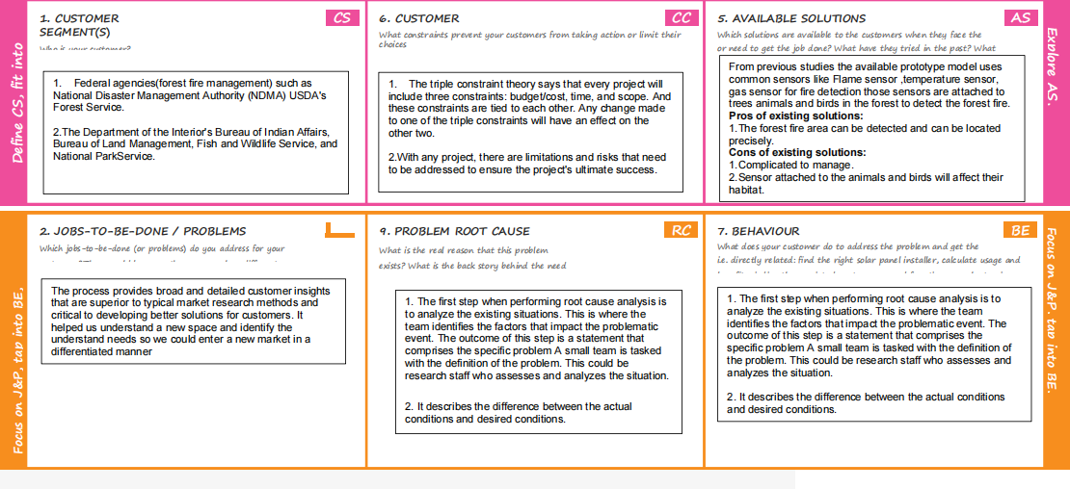

**4.REQUIREMENT ANALYSIS**

* 1. **Functional Requirements**

4.1.1.High Priority

1. The system shall take training sets of fire images and recognize whether there is a fire or the beginning of a fire (smoke) or if there is no fire
2. The system shall send a notification to the admin when it recognizes a fire in the image given
3. The system shall take real inputs of camera images and determine whether the image contains a fire or not
4. The system shall be able to take images with a variety of sizes and convert it to one fixed image to be used throughout the application.
5. The system shall run as a service on either a Windows or Linux operating system.
6. In the event that the computer on which the system is running shuts down, the system service should start automatically when the computer restarts

4.1.2.Medium Priority

1. The system shall provide following facility that will allow web pages that the user is permitted to access. The system must support the following facility:
   1. Send alert message
   2. Customer data management

4.1.3.Low Priority

1. The system shall allow the user's status to be stored for the next time he returns to the web site. This will save the user x minutes per visit by not having to reenter already supplied data.
2. The system shall provide information about event log of forest.

## **Non Functional Requirements**

## Non-Functional Objectives

## 4.2.1.Reliability

* + - The system shall be completely operational at least x% of the time.
    - Down time after a failure shall not exceed x hours.

## 4.2.2.Usability

* + - Customer should be able to use the system in his job for x days .
    - A user who already knows what camera he is using should be able to connect and view that page in x seconds.

## 4.2.3.Performance

* + - The system should be able to support x simultaneous users.
    - The mean time to view a web page over a 56Kbps modem connection shall not exceed x seconds..

## 4.2.4.Security

* + - The system shall provide password protected access to web pages that are to be viewed only by users.

## 4.2.5.Supportability

* + - The system should be able to accommodate many camera links.
    - The system web site shall be viewable from chrome or any browser.

## 4.2.6.Interfaces

The system must interface with

* + - The cloudant db for customer and customer log information
    - The acquired web site search engine.

# PROJECT DESIGN

## Data Flow Diagrams

**A Data Flow Diagram (DFD) is a traditional visual representation of the information flows within a system. A neat and clear DFD can depict the right amount of the system requirement graphically. It shows how data enters and leaves the system, what changes the information, and where data is stored.**

**Example:**

**FLOW**

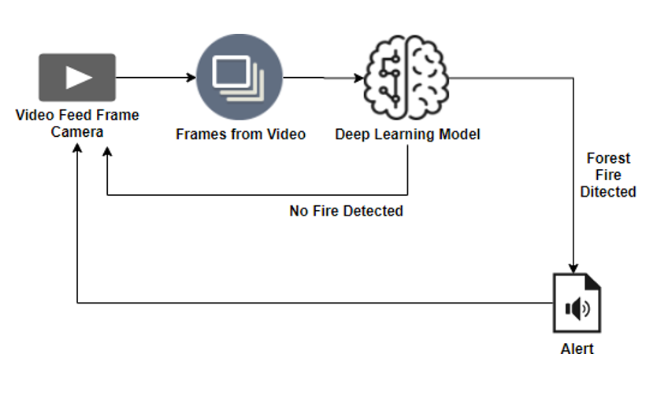

* It is difficult to predict and detect Forest Fire in a sparsely populated forest area.
* It is more difficult if the prediction is done using ground-based methods like Camera or Video-Based approach.
* Satellites can be an important source of data prior to and also during the Fire due to its reliability and efficiency.
* The various real-time forest fire detection and prediction approaches, with the goal of informing the local fire authorities.
* If the fire is not detected ,it will send the result to the frame camera.if the forest fire will detected the alert will go to the video feed frame camera.

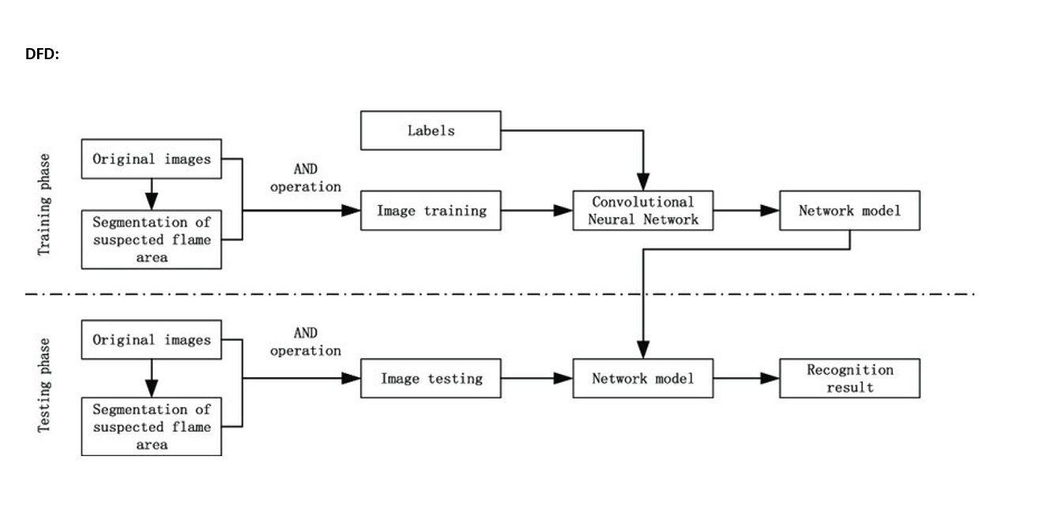

## **Solution & Technical Architecture**

Solution architecture is a complex process – with many sub-processes – that bridges the gap between business problems and technology solutions. Its goals are to:

* Find the best tech solution to solve existing business problems.
* Describe the structure, characteristics, behavior, and other aspects of the software to project stakeholders.
* Define features, development phases, and solution requirements.
* Provide specifications according to which the solution is defined, managed, and delivered.
  1. **User Stories**

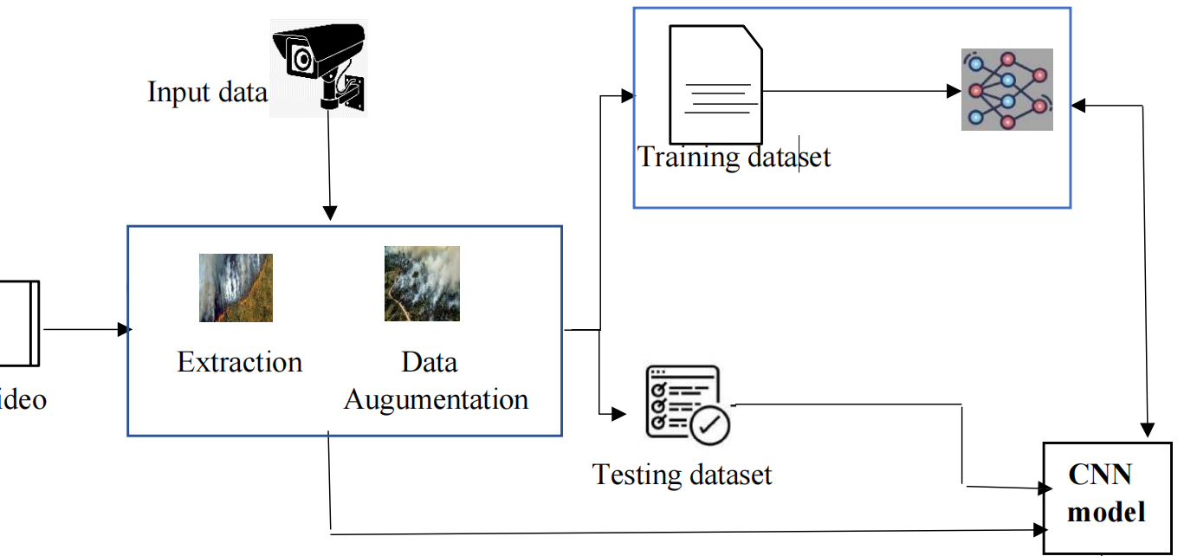

* 1. **User Stories**

Use the below template to list all the user stories for the product

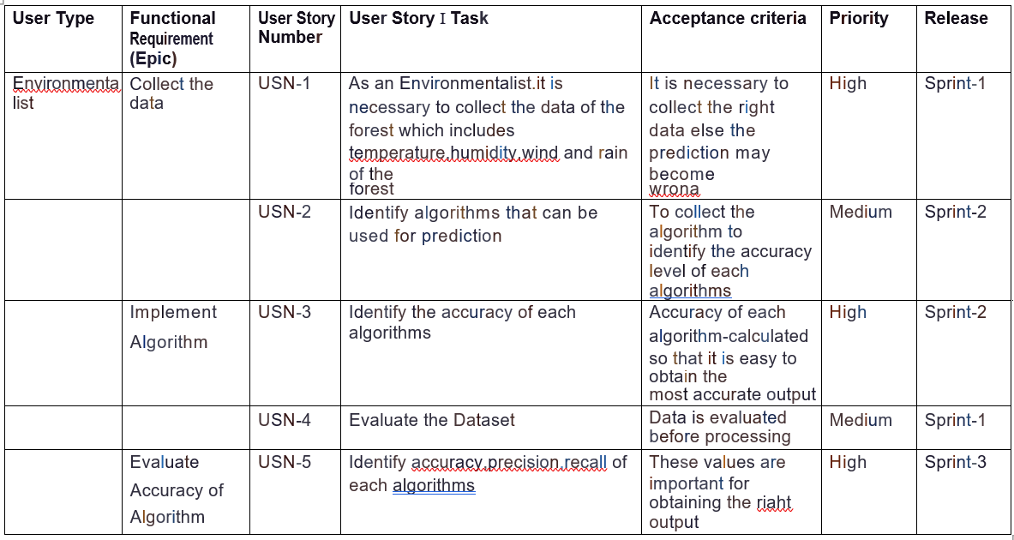

1. **PROJECT PLANNING & SCHEDULING**
   1. **Sprint Planning & Estimation**

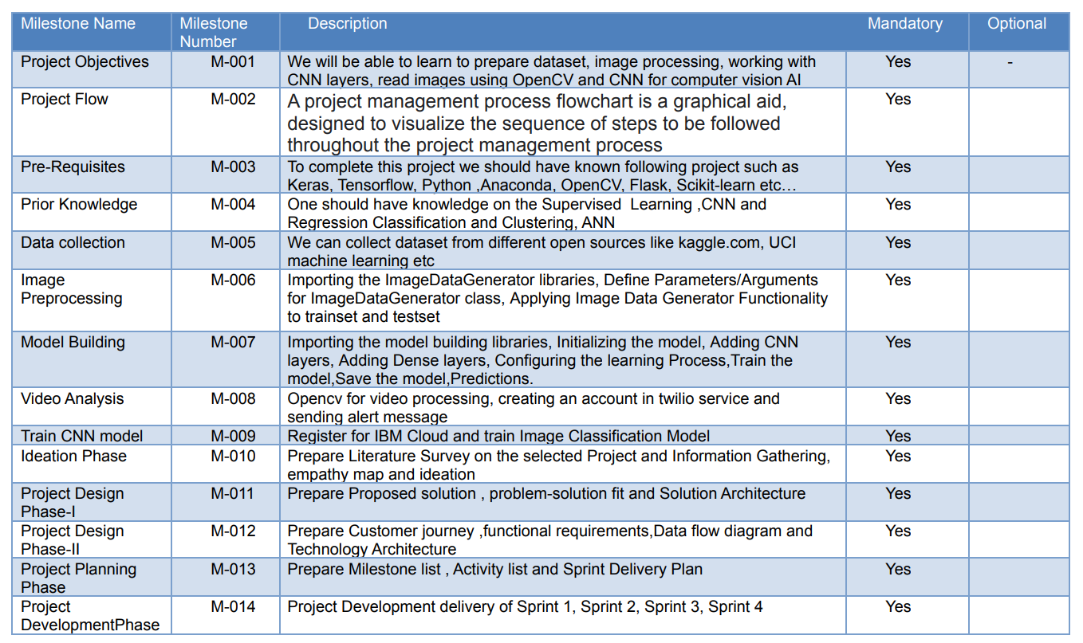

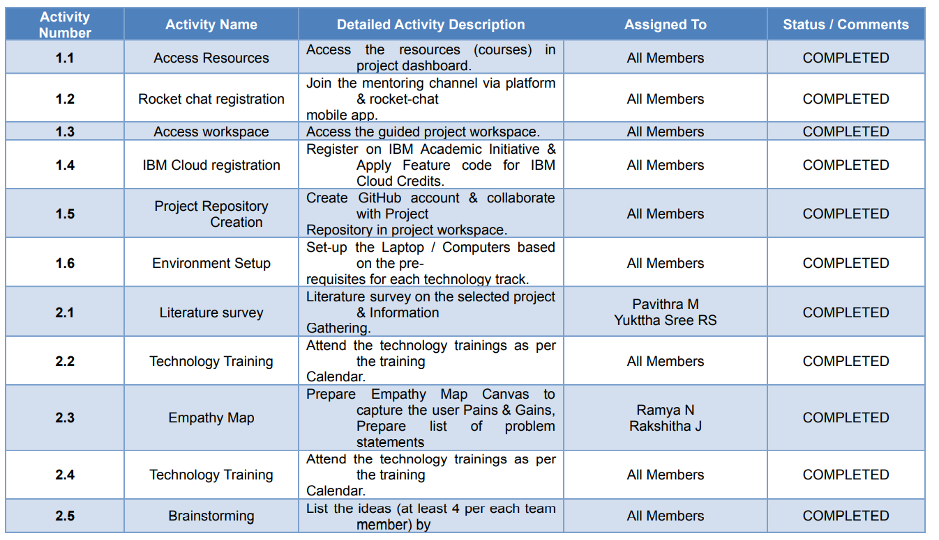

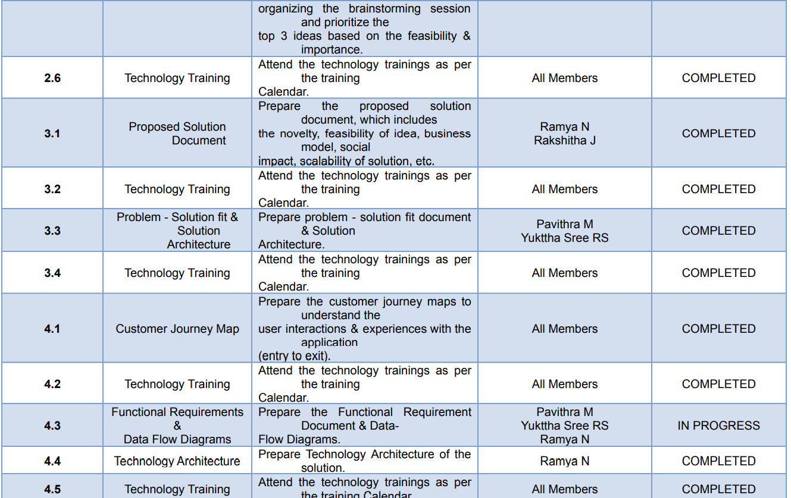

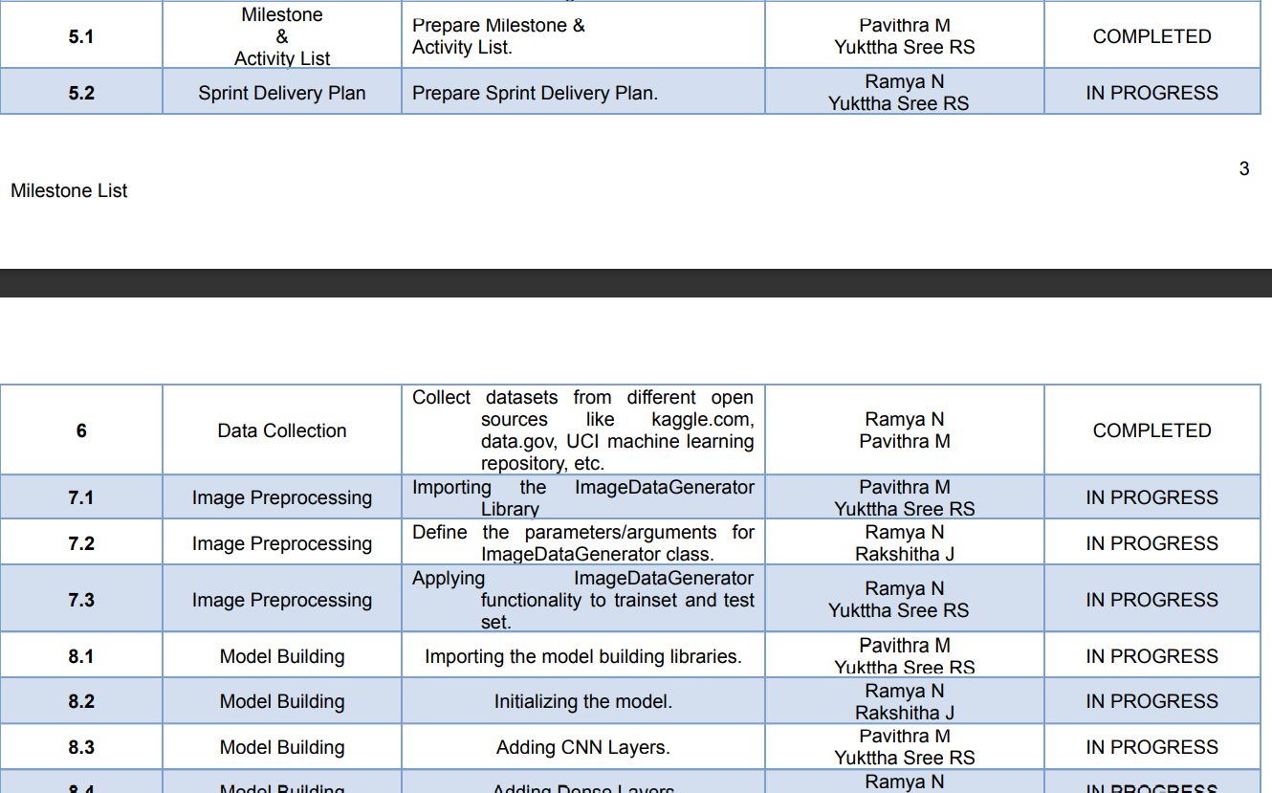

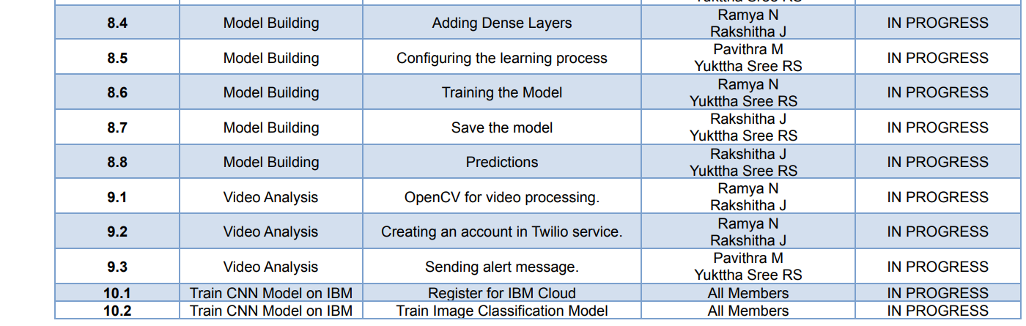

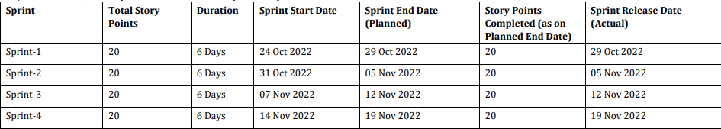 **6.2 Sprint Delivery Schedule**



* 1. **Reports from JIRA**

JIRA has categorized reports in four levels, which are −

* + 1. Agile
    2. Issue Analysis
    3. Forecast & Management
    4. Others

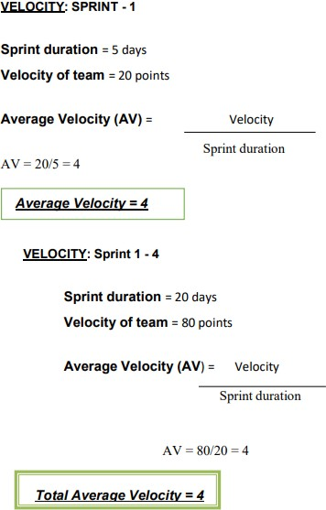

1. **CODING & SOLUTIONING (Explain the features added in the project along with code)**
   1. Feature 1

!pip install tensorflow

!pip install opencv-python

!pip install opencv-contrib-python

import tensorflow as tf

import numpy as np

from tensorflow import keras

import os

import cv2

from tensorflow.keras.preprocessing.image import ImageDataGenerator

from tensorflow.keras.preprocessing import image

train=ImageDataGenerator(rescale=1./255,

                                 shear_range=0.2,

                                 rotation_range=180,

                                 zoom_range=0.2,

                                 horizontal_flip=True)

train = ImageDataGenerator(rescale=1/255)

test = ImageDataGenerator(rescale=1/255)

train_dataset = train.flow_from_directory("/content/drive/MyDrive/Dataset/train_set",

                                          target_size=(128,128),

                                          batch_size = 32,

                                          class_mode = 'binary' )

test_dataset = test.flow_from_directory("/content/drive/MyDrive/Dataset/test_set",

                                          target_size=(128,128),

                                          batch_size = 32,

                                          class_mode = 'binary' )

test_dataset.class_indices

#to define linear initialisation import sequential

from keras.models import Sequential

#to add layer import Dense

from keras.layers import Dense

#to create convolution kernel import convolution2D

from keras.layers import Convolution2D

#import Maxpooling layer

from keras.layers import MaxPooling2D

#import flatten layer

from keras.layers import Flatten

import warnings

warnings.filterwarnings('ignore')

model =Sequential()

#add convolutional layer

model.add(Convolution2D(32,(3,3),input_shape=(128,128,3),activation='relu'))

#add maxpooling layer

model.add(MaxPooling2D(pool_size=(2,2)))

#add flatten layer

model.add(Flatten())

model.add(Dense(150,activation='relu'))

model.add(Dense(1,activation='sigmoid'))

model.compile(loss = 'binary_crossentropy',

              optimizer = "adam",

              metrics = ["accuracy"])

model.fit_generator(x_train,steps_per_epoch=14,epochs=5,validation_data=x_test,validation_steps=4)

model.save("/content/drive/MyDrive/archive(1)/forest1.h5")

predictions = model.predict(test_dataset)

predictions = np.round(predictions)

predictions

print(len(predictions))

#import load_model from keras.model

from keras.models import load_model

#import image class from keras

import tensorflow as tf

from tensorflow.keras.preprocessing import image

#import numpy

import numpy as np

#import cv2

import cv2

#load the saved model

model = load_model("/content/drive/MyDrive/archive(1)/forest1.h5")

def predictImage(filename):

  img1 = image.load_img(filename,target_size=(128,128))

  Y = image.img_to_array(img1)

  X = np.expand_dims(Y,axis=0)

  val = model.predict(X)

  print(val)

  if val == 1:

    print(" fire")

  elif val == 0:

      print("no fire")

predictImage("/content/drive/MyDrive/Dataset/test_set/with fire/19464620_401.jpg")

* 1. Feature 2

!pip install tensorflow

!pip install opencv-python

!pip install opencv-contrib-python

import tensorflow as tf

import numpy as np

from tensorflow import keras

import os

import cv2

from tensorflow.keras.preprocessing.image import ImageDataGenerator

from tensorflow.keras.preprocessing import image

train=ImageDataGenerator(rescale=1./255,

                                 shear_range=0.2,

                                 rotation_range=180,

                                 zoom_range=0.2,

                                 horizontal_flip=True)

train = ImageDataGenerator(rescale=1/255)

test = ImageDataGenerator(rescale=1/255)

train_dataset = train.flow_from_directory("/content/drive/MyDrive/Dataset/train_set",

                                          target_size=(128,128),

                                          batch_size = 32,

                                          class_mode = 'binary' )

test_dataset = test.flow_from_directory("/content/drive/MyDrive/Dataset/test_set",

                                          target_size=(128,128),

                                          batch_size = 32,

                                          class_mode = 'binary' )

test_dataset.class_indices

#to define linear initialisation import sequential

from keras.models import Sequential

#to add layer import Dense

from keras.layers import Dense

#to create convolution kernel import convolution2D

from keras.layers import Convolution2D

#import Maxpooling layer

from keras.layers import MaxPooling2D

#import flatten layer

from keras.layers import Flatten

import warnings

warnings.filterwarnings('ignore')

model =Sequential()

#add convolutional layer

model.add(Convolution2D(32,(3,3),input_shape=(128,128,3),activation='relu'))

#add maxpooling layer

model.add(MaxPooling2D(pool_size=(2,2)))

#add flatten layer

model.add(Flatten())

model.add(Dense(150,activation='relu'))

model.add(Dense(1,activation='sigmoid'))

model.compile(loss = 'binary_crossentropy',

              optimizer = "adam",

              metrics = ["accuracy"])

model.fit_generator(x_train,steps_per_epoch=14,epochs=5,validation_data=x_test,validation_steps=4)

model.save("/content/drive/MyDrive/archive(1)/forest1.h5")

predictions = model.predict(test_dataset)

predictions = np.round(predictions)

predictions

print(len(predictions))

#import load_model from keras.model

from keras.models import load_model

#import image class from keras

import tensorflow as tf

from tensorflow.keras.preprocessing import image

#import numpy

import numpy as np

#import cv2

import cv2

#load the saved model

model = load_model("/content/drive/MyDrive/archive(1)/forest1.h5")

def predictImage(filename):

  img1 = image.load_img(filename,target_size=(128,128))

  Y = image.img_to_array(img1)

  X = np.expand_dims(Y,axis=0)

  val = model.predict(X)

  print(val)

  if val == 1:

    print(" fire")

  elif val == 0:

      print("no fire")

predictImage("/content/drive/MyDrive/Dataset/test_set/with fire/19464620_401.jpg")

pip install twilio

pip install playsound

#import opencv librariy

import cv2

#import numpy

import numpy as np

#import image function from keras

from keras.preprocessing import image

#import load_model from keras

from keras.models import load_model

#import client from twilio API

from twilio.rest import Client

#imort playsound package

from playsound import playsound

#load the saved model

model = load_model(r'/content/drive/MyDrive/archive(1)/forest1.h5')

#define video

video = cv2.VideoCapture('/content/Fighting Fire with Fire _ Explained in 30 Seconds.mp4')

#define the features

name = ['forest','with forest']

account_sid='ACfb4e6d0e7b0d25def63044919f1b96e3'

auth_token='f9ae4fc4a617a527da8672e97eefb2d8'

client=Client(account_sid,auth_token)

message=client.messages \

.create(

      body='Forest Fire is detected, stay alert',

      from_='+1 302 248 4366',

      to='+91 99400 12164'

)

print(message.sid)

pip install pygobject

def message(val):

  if val==1:

    from twilio.rest import Client

    print('Forest fire')

    account_sid='ACfb4e6d0e7b0d25def63044919f1b96e3'

    auth_token='f9ae4fc4a617a527da8672e97eefb2d8'

    client=Client(account_sid,auth_token)

    message=client.messages \

     .create(

        body='forest fire is detected, stay alert',

        #use twilio free number

        from_='+1 302 248 4366',

        #to number

        to='+91 99400 12164')

    print(message.sid)

    print("Fire detected")

    print("SMS Sent!")

  elif val==0:

    print('No Fire')

from matplotlib import pyplot as plt

#import load model from keras.model

from keras.models import load_model

#import image from keras

from tensorflow.keras.preprocessing import image

img1 = image.load_img('/content/drive/MyDrive/Dataset/test_set/with fire/Wild_fires.jpg',target_size=(128,128))

Y = image.img_to_array(img1)

x = np.expand_dims(Y,axis=0)

val = model.predict(x)

plt.imshow(img1)

plt.show()

message(val)

img2 = image.load_img('/content/drive/MyDrive/Dataset/test_set/forest/1200px_Mountainarea.jpg',target_size=(128,128))

Y = image.img_to_array(img2)

x = np.expand_dims(Y,axis=0)

val = model.predict(x)

plt.imshow(img2)

plt.show()

message(val)

1. **TESTING**
   1. Test Cases



1. **RESULTS**
   1. Performance Metrics

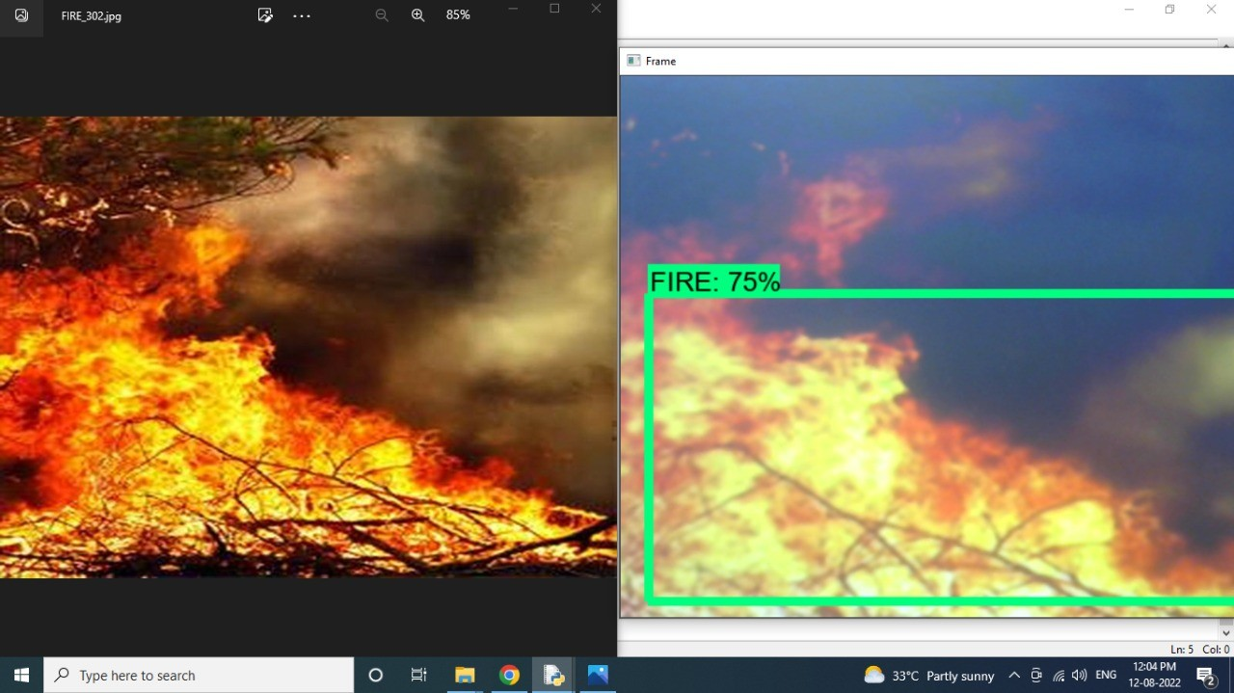

Value obtained from three sensor, if any Infrared ray detected, it gives output as IR detected, Sensor activated! Similarly, if there is any temperature change it will show Abnormal temperature and its intensity. For any smoke detection it output as Smoke detected and sensor value.Above image is result obtained from the trained ML model showing count for damaged and intact homes.

# ADVANTAGES & DISADVANTAGES

**Advantages:**

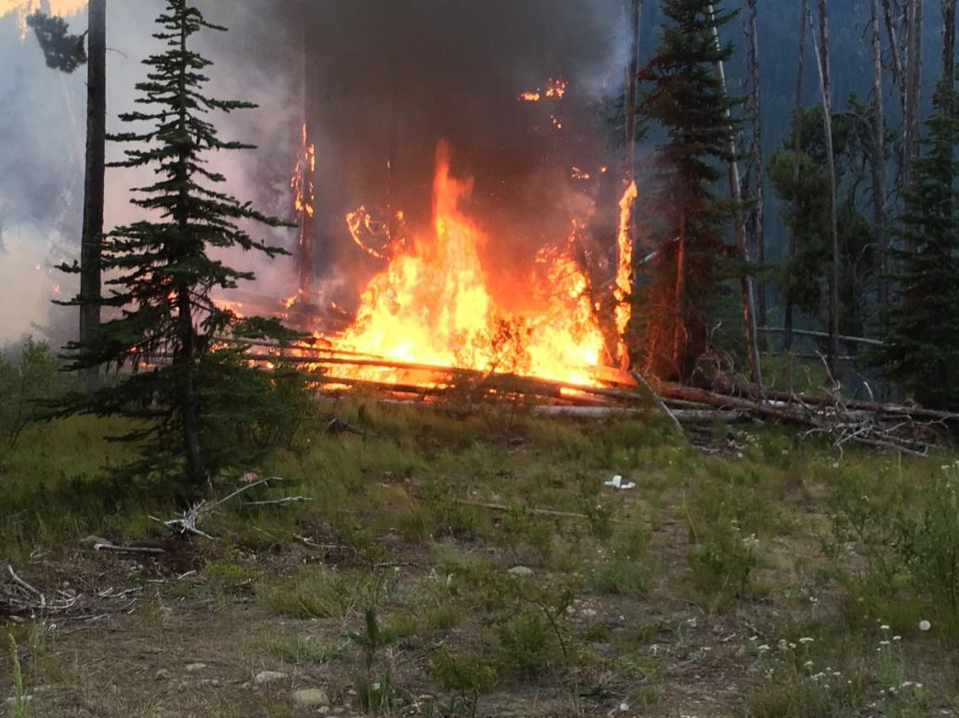

1. **It refreshes the habitat zones:** Fire clears out plants and trees to make more natural resources available to the habitat. Fewer trees mean more water becomes available for the remaining plants and animals that call the area their home. New grass and shrubs are food sources for a number of animals as well. A ground cover that comes back after a ﬁre becomes a new micro-habitat. Everything is refreshed with a ﬁre.
2. **Low-intensity ﬁres don’t usually harm trees:** The bark of a tree is like an armored shell against ﬁre, pests, and other things that could damage them. Most forest ﬁres burn at low- temperature levels when conditions are optimal and this causes minimal damage to the trees of the forest when it occurs. The end result is a clearing of the ground ﬂoor of the forest while the trees are able to continue standing majestically.
3. **Decreases the Wastes on Forests:** Forests have a lot of waste that ends up building up over time and these wastes can help create wildﬁres. If a large wildﬁre breaks out it might take weeks to control it and the damage it can cause is just too extensive to understand for us. Waste such as dead leaves on the ground can be pretty useful for wildﬁres to feed on and small forest ﬁres just deal with these wastes properly without going out of control.

# Disadvantages:

1. **A forest ﬁre sets up the potential for soil erosion to occur:** Forest ﬁres clear the underbrush away and encourage new growth, but there is a period of time between the ﬁre and the new growth where the forest is vulnerable.
2. **Forest ﬁres always bring death in some form:** Maybe it’s just the weak plants of the forest that are killed during a ﬁre, but there is always some sort of death that happens when a ﬁre occurs. Sometimes it is the ﬁreﬁghters who are tasked with stopping the ﬁre. It could be animals or pets.
3. **Uncontrolled ﬁres can cause localized air pollution:** Despite the amount of global development that has occurred, there are many forests that are diﬃcult or nearly impossible to reach. Fires in these areas are left to burn in an uncontrolled fashion and this creates air pollution which can affect the local environment and make it diﬃcult to breathe.

# CONCLUSION

This project will help in early detection of forest ﬁre and the prevention. It also involves the risk factor of analyzing the drone images of affected areas using machine learning algorithm which overcomes the existing project. This system detects the ﬁre conditions in a short time before any ﬁre accidents spreads over the forest area. The scope of using video frames in the detection of ﬁre using machine learning is challenging as well as innovative. If this system with less error rate can be implemented at a large scale like in big factories, houses, forests, it is possible to prevent damage and loss due to random ﬁre accidents by making use of the Surveillance System.

# FUTURE SCOPE

Future Scope In future, we are planning to install smart water tank system in dense forest where reachability of resources and ﬁreﬁghters is diﬃcult. In addition to that we will be updating the system with more features and reliability. We will also include a high pitch sound system that will keep away the animals from the site of ﬁre.The proposed system can be developed to more advanced system by integrating wireless sensors with CCTV for added protection and precision. The algorithm shows great promise in adapting to various environment.